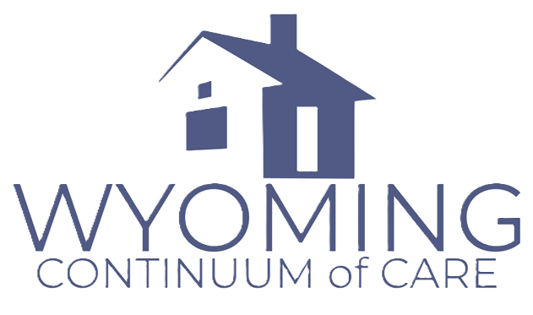

2026 New Project Application

Application Instructions:

Timeline:
Applications open June 29, 2026, and close July 20, 2026. Late applications will not be accepted.

Submission:
Submit two PDF files via email to anna.edwards@wycoc.org
- Application (completed form)
- Attachments (all required documents combined into one PDF)

File Naming Convention:
- Application file: AgencyName_ProjectType_NewProject_2026
- Attachments file: AgencyName_NewProject_Attachments_2026

Example:
- ABCOrg_PSH_NewProject_2026
- ABCOrg_NewProject_Attachments_2026

Attachment Requirements:
- Combine all required documents into one PDF file
- Clearly label each document within the PDF (e.g., “Attachment A – 501(c)(3)”)
- Submit attachments in the same order as the checklist

Page Limits:
- Section 0 (Agency Capacity): 2 pages max
- Sections 1–5 (Narrative): 10 pages combined max
- Budget Narrative: 2 pages max
- Total Narrative: 14 pages max
- Attachments are not included in page limits.

Formatting Requirements:
- 12-point font
- Standard (1-inch) margins
- Submit as PDF
- Complete all narrative sections using the provided application form

Incomplete or incorrectly submitted applications may not be reviewed or scored.

Part 1 — Cover Sheet
Instructions: Complete all fields. Ensure consistency with the application and budget. Commitments (e.g., CE, HMIS) may be provided if not currently implemented. Leave reviewer fields blank.

Project Information
Agency Name
Project Name
Grant Number (if applicable)
Project Component
Funding Type
Population Served
Household Type
Amount Requested

Key Project Metrics:
Metric | Value
Number Served Annually
Cost per Participant
Project Start Date (estimated)
Project Location

Part 2 — Threshold Eligibility & Certifications
Applicants must be able to demonstrate compliance with the following requirements. If not currently meeting a requirement (e.g., new applicants), provide a clear plan for how the requirement will be met.
☐ Eligible applicant entity
☐ Active SAM registration (UEI)
☐ No delinquent federal debt
☐ No debarment/suspension
☐ Meets HUD homeless definition
☐ Costs are eligible
☐ Meets match requirement
☐ Participates in, or commits to participate in, Coordinated Entry
☐ Participates in or commits to participate in, HMIS (or DVIMS for DV providers)
☐ No unresolved civil rights violations

Certification Signature: _______________________ Date: ____________

Projects that do not meet threshold requirements may not be reviewed or scored.

Part 3 — Project Narrative
Applications that provide clear, specific, and measurable responses will receive higher scores. General or unclear responses may receive partial or no points.

Section 0 — Agency Capacity & Organizational Readiness
Instructions: Provide specific examples. Applications lacking detail may not receive full points. Applications will be scored based on Agency Capacity, Project Design, System Outcomes, Services, Budget, and Strategic Priorities.
Response:

Section 1 — Population Served & Prioritization
Instructions: Include unsheltered focus, data, and Coordinated Entry prioritization. Include numeric estimates and describe how the project aligns with CoC prioritization policies.

Response:

Section 2 — Project Design & Readiness
Instructions: Include housing model, timeline, staffing, partnerships, and Coordinated Entry integration. Include specific details on how the project will operate day-to-day, including staffing roles and implementation steps.
Response:

Section 3 — System Outcomes & Performance
Instructions: Must include numeric targets: % housed, % income increase, % returns to homelessness, and average days to housing. Describe how the project will achieve these outcomes.
Response:

Section 4 — Supportive Services & Housing Stability
Instructions: Include service types, behavioral health supports, case management model, and partnerships. Describe frequency, intensity, and delivery method of services and how they support long-term housing stability.
Response:

Section 5 — Strategic Priorities
Instructions: Address unsheltered focus, recovery services, public safety, and innovation explicitly, and describe how these elements are integrated into the project design.
Response:

Part 4 — Budget & Cost Effectiveness
Instructions: Provide estimated annual costs for each category.
Line Item | CoC Request | Applicant Match | Total CoC Project Budget
Acquisition | $ | $ | $
Rehabilitation | $ | $ | $
New Construction | $ | $ | $
Rental Assistance | $ | $ | $
Leasing | $ | $ | $
Supportive Services | $ | $ | $
Operating Costs | $ | $ | $
HMIS | $ | $ | $
Rural Costs | $ | $ | $
VAWA | $ | $ | $
Budget Subtotal | $ | $ | $
Administration | $ | $ | $
TOTAL PROJECT BUDGET | $ | $ | $

Section 6: Budget Narrative
Instructions: Describe cost assumptions, cost per participant, and how costs align with project design, outcomes, and number served. Clearly explain how match will be used. Applications without detail may lose points.
Response:

Part 5 — Required Outcomes Table
Instructions: Provide numeric targets below. These should align with the proposed project design and services.
% Exit to Permanent Housing
% Increase Income
% Returns to Homelessness
Average Days to Housing
Number Served Annually

Part 6 — Application Checklist and Required Attachments
Applicants must submit the following.

Required Documents
☐ Proof of nonprofit status (e.g., IRS 501(c)(3) letter)
☐ Current SAM registration (printout)
☐ Most recent audited financial statements (if applicable)
☐ Organizational chart
☐ Board of Directors list
☐ Code of Conduct (if applicable)
☐ Most recent APR (if currently funded)

Project-Specific Documentation
☐ Partnership letters / MOUs (if referenced)
☐ Match documentation (commitment letters or equivalent)
☐ Budget justification support (if applicable)

Application Basics
☐ All required sections completed
☐ Budget aligns with narrative
☐ Outcomes table completed

Part 7 — Application Certification
Instructions: Authorized agency representative must sigh below
I certify that the information provided in this application is true, accurate, and complete to the best of my knowledge. I confirm that I am authorized to submit this application on behalf of the organization and that the organization will comply with all applicable CoC Program requirements if awarded.

Name (Printed) Title

Signature Date

